An exploration of the practical use of the Johari Window

Andrew Gibbons in a learning conversation with Rebecca Norton
Rebecca
We’re catching up after our webinar on Friday, which was really interesting. We were talking about the Johari Window, we invited people to come along and discuss this model with us, and it went really well. We didn’t record that session because we wanted everybody to be feel free to engage as much or as little as they wanted. We decided that we would have a bit of a reflection and a review session afterwards.
Rebecca
So this is what we’re doing today.
Andrew
It did go really well. We would say that, wouldn’t we? I think it genuinely did. We had an invited group of a small number of people. They were the right people with a very different, for such a small group, perspective on this. Some unfamiliar with the model, some familiar but hadn’t used it particularly deeply. Others probably have had a dabble, so we were able to take people deeper. I’m really pleased that I feel genuinely that people went away with something worthwhile.
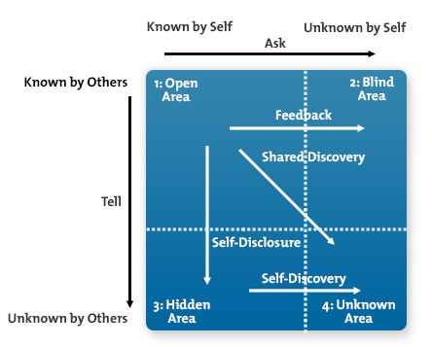
Andrew
It’s a visual informed by fifty-six adjectives, which Luft and Ingham put together in 1955, and those adjectives start the process of informing the size of the panes of the window. That’s a step I’m starting to realise a lot of people, however familiar with Johari, have never taken. Many haven’t taken the word-driven means by which you actually become informed about the pane sizes of the window through the different or similar perceptions of others to your views of yourself.
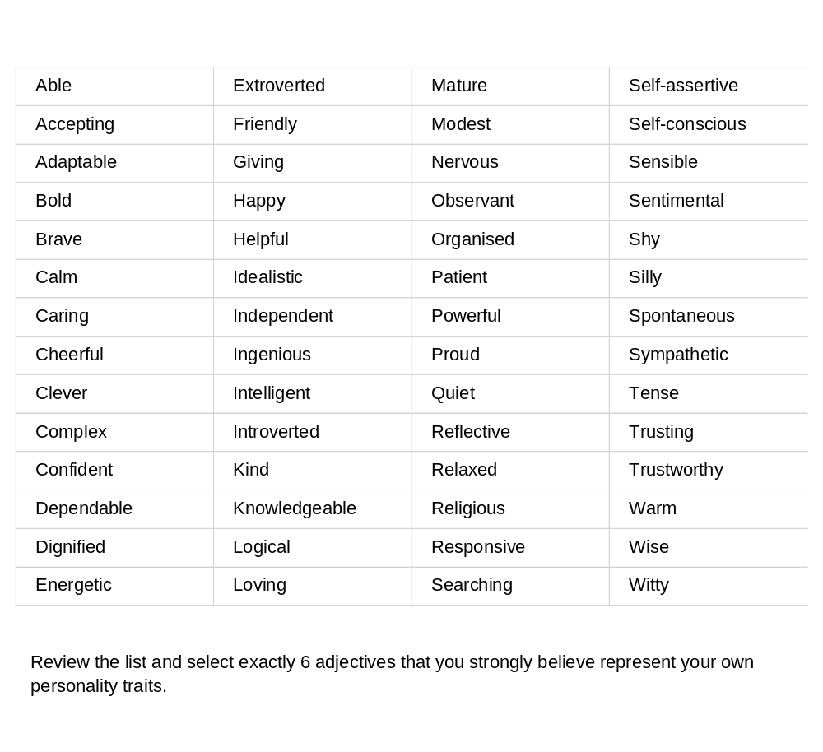Rebecca
The feedback I’ve had and you’ve had since suggests that people went away with new insights and value. I hope it means more use of the Johari Window.
Rebecca
So this almost feels like a natural step in terms of what do we do with the information we gathered from the webinar. We’ve had a brief catch up before this recording, and there are a few key themes that came out for us that are well worth reviewing and sharing.
Rebecca
What came up in the session was very interesting because we hadn’t really over-structured it and didn’t want it be all from us. It felt very organic.
Andrew
Organic is a word I feel is appropriate. We knew we’d be in the company of intelligent, informed, curious people, and didn’t want to get too ‘tutory’.
Andrew
And it’s too easily done when you get overexcited about something, certainly, in my case. Suddenly, I’ve been talking for eight minutes, and that’s seven too many. Let’s get into it, what particular issues do you want to start with in terms of what emerged from that Friday meeting?
Rebecca
I think one of the early points that was raised was around the feedback that people give within the Johari model. Somebody raised that it is only opinion rather than fact, and that was a really good point, that this is ‘just’ other people’s opinions, not ‘facts’.
Rebecca
And in that respect, it’s important to think about why you want to get feedback from other people in the first place, and who from whom you seek that feedback.
Andrew
You just gave me another new big issue to reflect upon - I’m writing this down because we’re starting with the ‘Only an opinion’ thing, then you just gave me ‘Why are we using this?’. What is the reason? Once again we see the serious power of interactivity - learning conversations really do prompt powerful insights. I have been thinking about this ‘only’ an opinion. It was very strongly and quite forcibly made. It’s only an opinion, and I guess every opinion, everything we feel about ourselves and others, is really, only an opinion.
Andrew
I’m saying that’s kind of how we relate to people. I might think you’re this or you’re that, and I could be completely wrong. But it’s still how I feel, and I might feel what I do about myself, and I know that’s only an opinion. It could be so strong it feels like fact. I think it’s a very interesting point. This for me, highlights that everything we feel about everyone, including ourselves, is only that – an opinion.
Rebecca
And just as you were saying that, it got me thinking that if several people, depending on how many people ask, had the same opinions of you, then could that make a difference?
Rebecca
Or are they all wrong? I think there’s something around that in terms of we’re getting the same opinion coming back many times. Perhaps it is an opportunity to look into that, is there a pattern that perhaps we need to explore around that area?

Andrew
I’ve worked with some people over the decades who would refute anybody’s views of themselves that are different to their own. ‘Everyone’s wrong, apart from me’. I’ve been forty-five years in the learning ‘space’, and I have come across a lot of people. Some of them are either deluded or amazingly accurate about their own self-perception to the point where other people’s opinions of them just don’t reach them.
Rebecca
And also, is that necessarily a bad thing? I think that’s the other point from this for me: It’s only useful if it’s useful. Somebody might think you’re not very good at whatever, but is it helpful information? It’s only for me. It’s all right hearing that, but unless I can do something with that information, then it’s of little help to me.
Andrew
We come back to principles of feedback, giving feedback only on what’s actionable rather than just giving opinions that can’t be actioned.

Andrew
I think the hub of the thing is it’s only opinions, and I think that’s something I’m going to think further about, as I haven’t completely worked this through, I have got to the point where I feel everything is an opinion.
Andrew
I do like the point you just raised. If, as we get more feedback from others to open the blind spot further, there’s a fairly general consensus on how we’re seen by people, does that impact on our self-perceptions? Would a rational person take heed of this? ‘I think I’m this, but these 38 people all think differently’ – so whose opinions have must value?
Rebecca
Like you said, I think there’s more on that one. The other thing that felt important to me was when we discussed the context of when you would use the Johari Window. The main context we were looking at on Friday was around the workplace, and as a coaching tool. I tend to do more personal coaching, and I know you tend to do more work-related coaching, with many people, in-organisation. I think being aware of the context in which we’re asking for that feedback was also a really key point from that Friday hour.
Andrew
I think that’s because on first acquaintance, if you look at the Johari window, it looks one-dimensional. ‘I think this about myself, these people think this of me. I’m holding this back from them, either deliberately or more likely, I suggest, unintentionally, and that’s it’. Domestically you might be one person. At work you might be another. As a boss you might be something else as seen by those with whom you work. As a member of a certain group or team in the workplace you might be different again. There’s so many contrasting potential Johari windows that could be very significantly different to each other, depending as you say, on the specific context.
Andrew
The way, we project ourselves, in different contexts is becoming interesting to me.
Rebecca
And for me, I don’t think this necessarily came up in the session, but I know we briefly spoke afterwards in terms of for me around the level of authenticity that is shown in any context. That’s one of my things at the moment, authenticity, and for me there was a strong link with that. I feel somebody who is able to be very authentic is probably less likely to change persona depending on the context. For some people, yes, like you said, it could change significantly depending on the context.
Andrew
Right, so you’re, suggesting to me, at least, unless I’m wrong, and I too often am, that if you’re a really authentic person, you can transcend context and still be seen as the same person in different contexts.

Rebecca
I might be wrong on that, but I feel that based on what I’ve been reading and learning about authenticity, the more we can be authentic around everybody the better for relationships in any context. It’s a lot to do with being confident and self-accepting of ourselves.
Andrew
Then the more authentic we can be, which means that we wouldn’t feel the need to change and adapt depending on the situation. Wow, there’s a lot in there.
Andrew
There’s indeed a lot in there, and I’m not even going to try and unpack it, just to parry it and say, ‘Wow, that’s something I need to think about,’ because I’ve kind of got locked into a mindset of you’re different people in different contexts in the company of different people with different roles to play. But I guess if your self concept is strong enough, you can be the person you are, irrespective of context. That’s something I’m not going to try and go into now because it would be too superficial. It’s certainly something else that interests.
Rebecca
And that’s the thing I took away and was pondering.
Andrew
I took away something else, and again, I’ve been reflecting on this a lot. I’ve written a lot of reflections on my recent use of the Johari Window because if I don’t I forget things easily. Something that came up in the webinar was when not to use it. This came up as one of the final comments of a contribution of somebody, and I thought, ‘Hey, I can’t let that go’, because, as with other tools, this may not be the right person, time, context or whatever. How good are we as facilitators of recognising an inappropriate use of a favoured model or tool?
Andrew
The wrong application could be a harmful use of any coaching tool that we like, from which we’ve got value previously, but in a particular context would be wholly inappropriate.
Rebecca
I think that is really important. We have to be very careful around why we’re using any coaching tool. What are our ultimate aims and agenda behind using it? Is it more about because we think this is a great tool, it’s worked well before?
Rebecca
How often do we answer the question ‘What do we want from using this tool?’.
Andrew
I think you’re right because clarity about the purpose should mean less likelihood of inappropriate application.
Rebecca
It came up Friday, that using the Johari Window inappropriately, like you said, can lead to harm. We all rightly stressed that working in this way with people, can be a sensitive issue. We’re talking about how other people perceive somebody or how they perceive themselves. Potentially, that can be quite upsetting or distressing, so you do need to use it very carefully, which is why you can’t just use it willy nilly and say, ‘Oh, well, it’s a great tool, so I’m going to use it anyway.’
Andrew
Absolutely, and again, I tried in the session we had to walk a bit of a balance between not trying to put people off, because it is in the right context a very powerful, very direct, very accessible, very simple to understand tool.
Andrew
Then it must be understood that it can create issues. It can prompt unintentional reactions from people. How well briefed are we? How well do we know the people we’re working with? I’ve certainly encountered people giving emotional reactions in events I’ve run that I didn’t expect. Sometimes that’s down to someone’s particular context that day, that week, that year, that we know nothing of. We just don’t know. Although we might feel this unlikely, it can create an emotional reaction. We’ve got to be responsible in the use of the Johari Window because we must recognise these and other issues.
Rebecca
I believe this came up after somebody asked about using this in a group coaching setting. Because individually, you’re still going to be careful how you use it, because this is, like we said it can be quite upsetting and distressing to have this feedback. So when you’re using it as a group, there’s even more things that you need to take into consideration, and especially what do you want to achieve from using the tool? Why are you using doing this? Is it going to help, or will it potentially lead to people feeling people very vulnerable and exposed.
Andrew
Are you going to be taken by surprise by the politics, the alliances, the hates?
The dynamics, baggage, history and much more within any group, and I would say particularly leadership ‘teams’ often need careful navigation, and any tool that makes previously hidden issues or blind spots more open and shared can lead to very unhelpful reactions and long term damage to key work relationships.
Andrew
Ultimately, we must take responsibility for what we do. It’s best to be informed about the possible reactions of people in the room and what would work and what wouldn’t. How full or accurate are these briefs if ever given? There is so much more to explore as ever.
Rebecca
I agree, and my summary of the session is that it was very enjoyable. I think the fact that we kept it a relatively small group (eight plus ourselves), meant that nobody felt lost in the session. There was a lot of engagement, and the fact that we had people from different backgrounds, roles and responsibilities brought in different perspectives.
Rebecca
And that was interesting for me, because there were points that people raised that I hadn’t considered. So actually, having that group discussion was really helpful in terms of helping me see how I might use the Johari window, and just as importantly how I might not use it. It clarified for me what the benefits are, and what some of the things that I would need to consider before I chose to use that with people.
Andrew
Absolutely, for me, it was about sharing the experience of going into this powerful tool at a deeper level. It’s lot more than a visual.
Andrew
Two simple ideas: Develop the ‘Open’ pane of the window through seeking and reflecting upon feedback and shrink the ‘Hidden’ pane through selective disclosure.
Rebecca
I think that deeper, word-led exploration is what got people interested. I know this model, but I haven’t used it in that depth before.
Rebecca
And that was what I took away from it: it’s given me a different perspective on the actual tool, and it’s also given me more confidence in applying this because I know what its values and strengths are and where I would be much more informed, and when appropriate, cautious around using it.



Any thoughts fellow practitioners?

