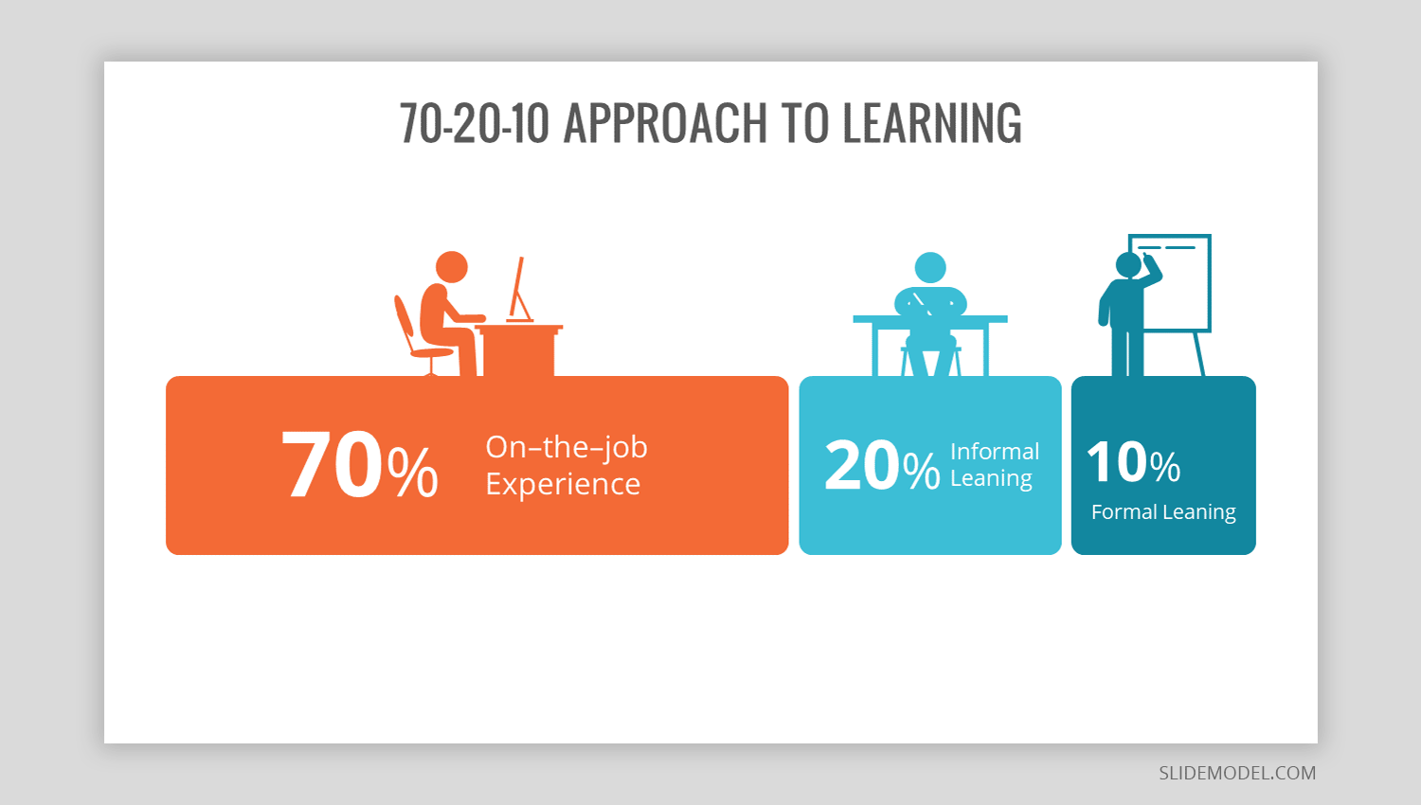

**The 70:20:10: model – 100% beyond most organisations**

Andrew Gibbons

Like most Learning and Development folk, I am ‘aware’ of the 70:20:10 model popularised most recently by Charles Jennings, as illustrated above, emphasising informal learning over ‘training’.

I won’t explain the model, there isn’t space here for that – in summary Jennings rightly emphasises self-driven, real-world learning experiences, and seriously questions the value of most structured, group-based ‘training’ events. Yes there is a role for the latter, not ‘though as the default development option, simply because this is embedded practice and is administratively most convenient.

Hard to argue against that in principle, and intuitively we surely know that most of what we need to do our jobs well, was not taught on a course, it has been learned in the ‘real’ world, doing that job.

The trouble is, the simplicity of the model contrasts with the seismic shift required in the learning patterns of individuals; the largely passive development roles of line management, and of the embedded delivery modes of organisations, which for decades have spent very serious money in the 10% section.

Oh dear.

Jennings suggests that high performers typically:

Have mastered the basics of their craft in a structured way

Have carried out a lot of practice under guidance

Are embedded in a professional community

Have access to the people and tools required to perform

Usually have thousands of hours of practice

This is interesting, as well as alarming for those for whom this seems a lot more work than they are prepared to take on to realise anything like their potential.

Jennings does not rubbish all structured learning activity. The best of this can front-load a high performer’s career path by providing the tools, ideas, models, and skills that give an early boost that in turn creates momentum the individual must then sustain by practice, network development, advice-seeking and never ever, losing the appetite to learn.

He further helps us by saying that the 70:20:10 model is ‘scaffolding – a framework for change’. He at all times emphasises that the model is a platform from which to create higher performance by continuous learning.

It is worth reminding ourselves that ‘high performers’ require nurturing, initially, benefiting from structured learning. Additionally comfort within the 70% is an evolutionary process - the best then accelerate at a rate way beyond those passive participants who prefer sitting on chairs being told things they feel they already know. The time to drive your own development really is now.

Jennings provides four qualities required to maximise the value of learning:

Rich and challenging experiences

The opportunity to practice

Meaningful conversations

Taking time out for reflective practice

Oh dear again.

The question I ask is ‘how many organisations really, and I do mean truly, design and deliver learning in a way that is driven by individual and specific needs in this way?’.

Furthermore, how many non-needs based, administratively convenient, training courses genuinely provide hungry, ambitious, eager people with the content and the opportunity to learn and to apply that learning so it creates serious measurable returns in the workplace?

So, we have a problem, well more than one, here are just three big ones that standout for me.

Those with the greatest potential to become really high performers do not want an unhelpful emphasis on prescriptive, what Jennings calls ‘pull’ learning events. They after a time, have the capability to ‘push’ their own development path, less formally, and far less ‘managed’.

Unless the right individualised path is designed, and unless they are genuine empowered partners in a tailored process, they will leave, seeking that sophistication of practice elsewhere.

Next, let’s consider line managers, Jennings is explicit in their critical role in making the 70:20:10 model work. He says succinctly, ‘without the line manager, you can’t do it’.

If an organisation is to truly make the workplace the primary source of development, we need a lot more line managers who accept that coaching and facilitating learning is a key part of their job. This means finding room for a new element of a line manager’s role amidst so many operational tasks.

In addition, they must be upskilled to make them capable of doing this well, and their operational expectations must be managed such that they have the time and space to fulfil their developmental responsibilities. Then there are those incapable or unwilling to do this…

Finally we need to think about whether the development function, and those charged with its delivery and spend are up for this huge shift in role and emphasis. Despite some very impressive talk around this model, I still see an awful lot of classroom training going on in most places I frequent.

I fear that too many who for too long have been in the ‘trainer’ role will find it beyond them to adapt to a radically different way of supporting learners who favour a far more informal, self-managed career path. As well as this, better measures of value from development spend than days spent sat on chairs must become the norm.

In conclusion, I never despair, I do however, have very real concerns around the genuine implementation of this wonderfully simple, hugely challenging model.

andrew@andrewgibbons.co.uk www.andrewgibbons.co.uk